A project report

On

Appetite Manager

Submitted in partial fulfillment of the requirement of Project – III BIT278CO

Of

Bachelor of Information Technology

**Submitted to**



Purbanchal University

Biratnagar, Nepal

**Submitted By**

Suyog Adhikari

Uttam Kharel

Arpana Guragain

**KANTIPUR CITY COLLEGE**

Putalisadak, Kathmandu

24 May, 2019

A project report

On

Appetite Manager

Submitted in partial fulfillment of the requirement of Project – III BIT278CO

Of

Bachelor of Information Technology

**Submitted to**

Purbanchal University

Biratnagar, Nepal

**Submitted By**

Suyog Adhikari (331147)

Uttam Kharel (331748)

Arpana Guragain (331127)

**Project Supervisor**

**Mr. Raju Kattel**

**KANTIPUR CITY COLLEGE**

Putalisadak, Kathmandu

May 24, 2019

**TOPIC APPROVAL SHEET**

It is hereby informed that the topic selected by Suyog Adhikari, Uttam Kharel and Arpana Guragain of BIT III semester for their semester project has been found suitable and as per the credit assigned by Purbanchal University (PU), Biratnagar, Nepal.

The project Committee has approved the following topic for the above-mentioned students.

Topic Approved: Appetite Manager

|  |  |  |
| --- | --- | --- |
| ________________ | ________________ | __________________ |
| Mr. Ashim KC | Mrs. Bhawana Bam | Mr. Bikash Neupane |
| Coordinator BCA, BIT | Asst. Lecturer, Department of IT | Project Coordinator |

**CERTIFICATE FROM THE SUPERVISOR**

This is to certify that the project entitled “Appetite Manager” submitted by Suyog Adhikari, Uttam Kharel and Arpana Guragain to the department of Information Technology, School of Science and Technology at Kantipur City Collage, Kathmandu, Nepal towards the requirement for BIT278CO of is an original work carried out by them under my supervision and guidance.

Signature:

________________________

Mr. Raju Kattel

Department of Information Technology

(Project Supervisor)

Place: Kantipur City Collage, Putalisadak Kathmandu

Date: 24 May 2019

# **ACKNOWLEDGEMENT**

We would like to express our deepest appreciation to all those who provided us the possibility to complete this report. We would like to acknowledge with much appreciation the crucial role of the staff of Kantipur City Collage, who gave us the permission to use all required equipment and the necessary materials to complete the task.

Furthermore, special thanks to our project supervisor, Mr. Raju Kattel, whose contribution in stimulating suggestions and encouragement, helped us to coordinate our project especially in writing this report also suggesting us about the task and guiding us during the completion of this project. Finally, many thanks to lab in-charge for providing the facilities of lab during our project. We must appreciate the guidance given by other supervisor as well as the panels especially in our project presentation that has improved our presentation skills, thanks to their comment and advices.

# **ABSTRACT**

In the modern world of today, the people have been living a technologies-based life. The progression of human society has developed most of its aspects into new standards. Machineries and technologies have leapt through the times in a tremendous pace into development. To keep up with the technological advancement in restaurant business, this project on ‘Appetite Manager’ was built.

We purpose to build a software that can efficiently handle and manage various activities of a restaurant and all those activities happening under the supervision of the administration. The business in restaurants are now growing constantly. At the same time, the need for managing its operations and tasks arises. Restaurants workers/owners should no longer go through the irritating process of going through the written records and book keepings. All those information and overall activities are provided by a simple software. In today’s generation using software for business enhancement takes huge position.

**TABLE OF CONTENTS**

ACKNOWLEDGEMENT i

ABSTRACT ii

LIST OF FIGURES iii

LIST OF TABLES iv

ABBREVIATION v

Chapter 1: Introduction 1

**1.1** **Project introduction** 1

**1.2** **Problem Statement** 1

**1.3** **Objective of the project** 2

**1.4** **Significance of the project** 2

**1.5** **Features of the project** 3

**1.6** **Assignment of Roles** 3

**1.7** **Documentation Organization** 4

Chapter 2: Existing System’s Overview 5

**2.1 TOAST POS** 5

**2.2 Belna (Restaurant Management System)** 5

Chapter 3: System Analysis 7

**3.1 System development model** 7

**3.2 Requirement Specification** 8

**3.2.1 Functional requirement** 8

**3.2.2 Non-functional requirement** 8

**3.3 Feasibility study:** 8

**3.3.1 Technical feasibility:** 8

**3.3.2 Economic feasibility:** 9

**3.3.3 Operational feasibility:** 9

**3.3.4 Schedule feasibility:** 9

Chapter 4: System Design 10

**4.1 Context Level Data Flow Diagram** 10

**4.2 Level 1 Data Flow Diagram** 11

4.3 ER Diagram 12

12

Chapter 5: System Development 13

Chapter 6: Conclusion and Future Enhancement 14

# **LIST OF FIGURES**

|  |  |  |
| --- | --- | --- |
| **Figure no.** | **Figure** | **Page no.** |
| 1.1 | Waterfall Model | 9 |
| 2.1 | Context Level Dataflow Diagram | 12 |
| 2.1.1 | Level 1 Data Flow Diagram | 13 |
| 2.2 | Entity Relation Diagram | 14 |
| 2.3 | Use case Diagram | 15 |
| A | Home Screen | 19 |
| B | Menu Display | 19 |
| C | Table Data Loader | 20 |
| D | Membership Sign Up | 20 |
| E | Add New Dish | 21 |
| F | Remove Existing Dish | 21 |
| G | Login Screen | 22 |

# **LIST OF TABLES**

|  |  |  |
| --- | --- | --- |
| **Table No.** | **Table** | **Page no.** |
| 1 | Assignment of Roles | 5 |
| 2 | Testing and Debugging | 17 |
|  |  |  |
|  |  |  |
|  |  |  |
|  |  |  |
|  |  |  |

# **Chapter 1: Introduction**

## **Project introduction**

Appetite Manager is an application which will help restaurant to optimize and have control over their restaurant. On the verge of technical advancement many restaurants still work by the classical method of normal book keeping, which is lengthy and confusing work. However, with this system It basically makes the work of billing and other restaurant management activities easy. Also, from the management point of view, the manager will be able to know about the financial activities like income, profits, and flow of costumers in their restaurants in daily as well as monthly basis. The system also possesses the records of each employee so that most of the heavy work of record keeping is minimized.

The main goal is to maintain the restaurant’s functions in an effective and accurate manner by reducing the use of manual entries with using database system.

## **Problem Statement**

After going through few restaurants and observing their record keeping system, we realized that 8 out of 10 restaurants still use pen and paper as their record keeping. They mentioned about the tiresome work that had to be done mostly at the end of the day or even month for maintaining their monthly statement as well as daily record. Managers also stated about the fraud activities done by the staffs as the record they had was not reliable, and could be easily modified by anyone.

These problems are not only about single restaurant but many restaurants are going through similar situations. They have huge number of customers, they obviously need the help of some features so they can maintain and store the records accurately. For managers it is difficult to view the tables, orders, kitchen, reception and the counter simultaneously. They need full-fledged software to maintain their day to day transactions, orders and also regular update on records, cash transactions, daily staffs report, customers feedback etc. In the existing system, entering all the details are done manually, it takes a lot of time and some experience to perform those tasks and still there are chances of errors and frauds.

## **Objective of the project**

The main objective why this project is created are

* to provide the restaurant owners fully efficient record storing system,
* to minimize the fraud activities done by the restaurant’s owners,
* to accommodate huge amount of orders at a time, and automatically compute bills
* to maintain the financial records for the management

## **Significance of the project**

The significance of integrated restaurant management system is very important in the restaurant business these days. From the time when these systems were used as a mobile cashier to the time when they are use for overall management activities of the restaurant.

The following are the significances of Restaurant Management Software:

* Restaurant Management Software system manages inventory, facilitates order management and assists in many restaurant’s day to day tasks.
* Boosting customer’s loyalty by to using features such as coupons, as well as extensive gifting options.
* Faster services including efficient billing and proper order management.
* Proper financial communication between manager and staff.

## **Features of the project**

Some of the features of Appetite Manager are as follows:

* The prime feature of the system is to track the sales and services provided by restaurant itself.
* Clear billing system about the expenses done by the customer including loyalty coupon number.
* Extensive discount system, if the coupon number from previous service is brought.
* Special discount for those who sign up as a membership.
* Prepare diagrammatic or numeric account for daily as well as monthly activity of the restaurant.

## **Assignment of Roles**

|  |  |  |  |
| --- | --- | --- | --- |
| **Group Member** | **Roll no.** | **Activity** | |
| Suyog Adhikari | 331147 | Contribution to overall interface, Diagrams, Menu Design, Coding, Database, Environment analysis, Searching. | |
| Uttam Kharel | 331148 | Contribution to designing Data Flow Diagrams, ER diagrams, Login and security, Database Entry, Interviews for requirement gathering and Simple Interface designs on Delivery System. | |
| Arpana Guragain | 331127 | | - |

Table no. 1: Assignment of Roles

## **Documentation Organization**

Documentation on Restaurant management system is composed of the following parameters.

**Chapter One**

We have discussed about the basic concept of the project on this chapter. The chapter has also stated about the features, objectives and the existing problems that are being faced by the expanding restaurants with higher possibilities.

**Chapter Two**

We have discussed about the existing systems that the local as well as global market is using on daily basis regarding the Restaurant Management System. This chapter deals with the advantages as well as disadvantages of using these systems and how we can add or improve the features on our system and minimize the disadvantages.

**Chapter Three**

Chapter three discusses about the model that fits the process of development of this project. We used waterfall model during the development of the system. This chapter shows the diagrammatic representation on how the various activities were done to develop this project. Chapter 3 is also about the functional as well as non-functional requirements of the project as well as its feasibility in various aspects.

**Chapter Four**

Chapter Four is about how the system is designed. All the various data flows and the basic working of the system is outlined in the DFD and ER diagram.

**Chapter Five**

Chapter Five of the documentation states about the working environment of the system. This chapter states the system requirement, the tools that were used to develop the system and also the tools that are needed for another device to run the program,

**Chapter Six**

Chapter 6 concludes the project with overall overview on how Appetite Manager was made. Chapter 6 also mentions about the limitation that the system has and the future improvements that can be don’t on having further information and knowledge on the given system.

# **Chapter 2: Existing System’s Overview**

During the preparation of this project we came through many different existing projects. Some of which are mentioned below.

## **2.1 TOAST POS**

Toast is a cloud-based Restaurant Management and Point of Sale system built in Cambridge Massachusetts in 2012 by Steve Fredette, Aman Narang and Jonathan Grimm. This is a System in which restaurants of all kinds like dinner restaurant, fast food restaurant or even cafes can use its functions. The pros and cons that we encountered while researching about the system in the internet, using its demo version by ourselves and also asking to the users who are using it we came to the following conclusion.

**Pros of TOAST POS**

* TOAST provides efficient cloud base data storage for safe storage of their data.
* They provide monthly and daily record on purchase vs sales graph.

**Cons of TOAST POS**

* There is no any feature to provide merits to loyal/regular customers.
* TOAST POS lacks membership feature as a marketing strategy.

## **2.2 Belna (Restaurant Management System)**

Belna is a system that was designed and developed by developers from Nepal. According to the developers this system was initially developed to serve a specific organization. However, with high demand of such system that could reduce the use of traditional record keeping and have efficient order management the areas belna could serve was expanded. On visiting the restaurants that used the software and interviewing the developers the good and bad aspects of belna was as below:

**Pros of using Belna System**

* As all the tables in the restaurants has their respective ordering device, it no longer necessary for the customers to wait until the waiter is free.
* Payment can be done via internet with mobile banking as well as cash.
* The acquired records are uploaded online so that there is less chance of data loss on hardware failure.
* This system provides loyalty points to regular users.

**Cons of using Belna System**

* Need stable internet access for the customers effective order items.
* This being an online system security breach or server crash may occur.
* Regular Maintenance on servers is necessary.

# **Chapter 3: System Analysis**

## **3.1 System development model**

The development of the project “Appetite Manager” strictly follows the waterfall model which is because of the small size of the project and also with the requirement which is less in amount and can be gathered at once.

Background study

Requirement analysis

System design

Coding, testing and debugging

Implementation

Fig 1.1: Waterfall model for development of the project.

## **3.2 Requirement Specification**

After the selection of the SDLC process, then the first thing we did was to specify the requirement, which has been divided into two parts according to the requirement of the system.

### **3.2.1 Functional requirement**

* **Purpose:**

The main purpose of the system is to manage the restaurant more effectively and efficiently by computerizing meal ordering, billing and inventory control.

* **Security:**

The crucial part of this system is to authenticate genuine admin login for the modification of the system menus and generating report.

### **3.2.2 Non-functional requirement**

* **Usability:**

Appetite Manager is staff end system which helps the restaurant’s management to have data and information stored in a database that reduces data redundancy. Although customers cannot use this system. Most of the functionalities are developed to benefit customers as well as the admins.

* **Security:**

Some crucial information that are only to be accessed by the people who has administrative privilege can access it with the help of administrative password. This system provides one layer of security to those data.

* **Membership Option:**

As any customer signs up as a member he\she will have benefit to enjoy the discount provided by the system.

* **Instant Ordering:**

In case the staff has to accommodate huge orders to different tables. This system can manage all those orders within a single page and can specify orders with respect to ordered table simultaneously.

## **3.3 Feasibility study:**

The major purpose of this project to describe a proposed system that can not only be used for ordering and billing food items such a system that is feasible and compatible to most of the existing system and upcoming systems.

### **3.3.1 Technical feasibility:**

The system is created to match the technology which is found in almost all the recent computers. There is no any special hardware requirement that has to be attached separately. Hence, we believe that the designed system is technically feasible.

### **3.3.2 Economic feasibility:**

Here we deal with the cost benefit of the project. Since this project is developed to meet our academic project, therefore there is no any additional funding process involved. As the tools used for the project development are completely free so the study of the process was skipped.

### **3.3.3 Operational feasibility:**

During these studies we studied whether the system is either socially accepted or not, and the system follows the policy of the organization. And the labor required after the completion of the system.

### **3.3.4 Schedule feasibility:**

|  |  |  |  |  |  |  |
| --- | --- | --- | --- | --- | --- | --- |
| Process  Week | 1 | 2 | 3 | 4 | 5 | 6 |
| Idea presentation |  |  |  |  |  |  |
|  |  |  |  |  |  |
| Background study |  |  |  |  |  |  |
|  |  |  |  |  |  |
| Requirement analysis and gathering |  |  |  |  |  |  |
|  |  |  |  |  |  |
| Coding and testing |  |  |  |  |  |  |
|  |  |  |  |  |  |
| documentation |  |  |  |  |  |  |
|  |  |  |  |  |  |

Overall process and time taken with estimated time of completion are expressed on Gantt chart below:

|  |  |
| --- | --- |
| Estimated Time |  |
| Time Taken |  |

# **Chapter 4: System Design**

## **4.1 Context Level Data Flow Diagram**

Figure 2.1: Context Level Data Flow Diagram

## **4.2 Level 1 Data Flow Diagram**

Fig: 2.1.1 Level 1 Data Flow Diagram

# **4.3 ER Diagram**

## 

Fig 2.2: Entity Relation Diagram

## **4.3 Use Case Diagram**

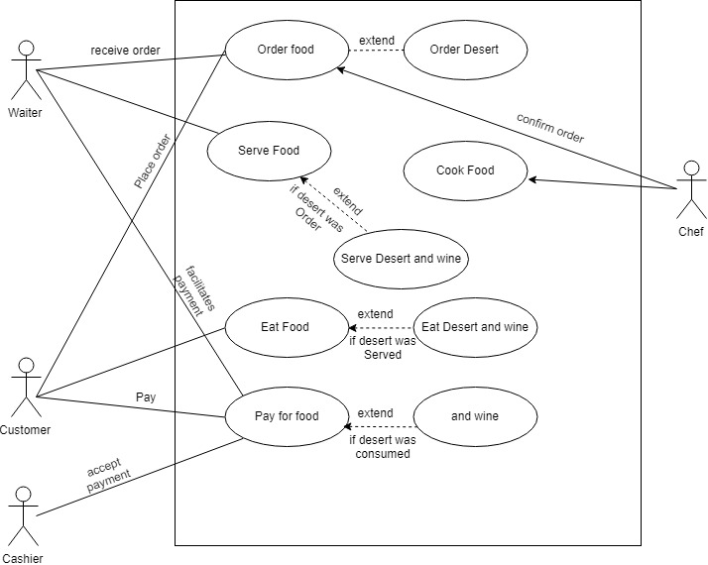

Fig 2.3: Use Case Diagram

**Chapter 5: System Development**

The project on Appetite Manager was developed with different development tools and framework. This chapter enlists the tools and technologies that were used to develop the system.

## **5.1 Programming Platform:**

* **Front end**: Visual studio (C#, with .Net 8.6.1 framework)
* **Back end**: MySQL

## **5.2 Operation requirement**

The minimum requirement for the system to run is:

### **5.2.1 Hardware details**

* Minimum 1 GB RAM
* 2 GB or above Hard Drive
* Intel Dual core processor or higher

### **5.2.2 Software details**

* **Operating system:** Windows XP or Higher
* **Framework:** .NET framework 8.6.1 or Higher

## **5.3 Testing and Debugging**

Testing begins at the module level and works outward towards the integration of the entire computer-based system. Different testing techniques are appropriate at different level of the time.

|  |  |  |
| --- | --- | --- |
| S.N. | Test Objective | Result |
| 1 | Checking weather program runs or not | Passed |
| 2 | Working of Login System | Passed |
| 3 | Check weather all the menus and function work or not | Passed |
| 4 | Check weather membership is added as well as customer’s info is saved | Passed |
| 5 | Test weather login system is updated or not | Passed |
| 6 | To check weather the system generates bill or not | Fail |
| 7 | To check weather income statement is printed or not | Fail |

Table 2: Testing and Debugging

# **Chapter 6: Conclusion and Future Enhancement**

## **6.1 Conclusion:**

The system as a whole act as an important tool to any restaurant owners and employees because of its easy to use interface, attractive layouts, efficient data storage and management. Since the system is developed with least amount of heavy resources it can run on any common computers. However, there are many limitations that the system could not achieve due to lack of time, and sufficient knowledge to given programming language which of those are as mentioned below.

## **6.2 Limitation:**

* The software cannot be used by customers
* Since it is an offline system there may be higher chance of data loss or fraud.
* Offline system may provide some comfort to the user but, it is not completely efficient to use in bigger organizations.

## **6.3 Future enhancement:**

As upon the shortage of the time period we were unable to add some of the features and the software can be maintained by checking the error during long time usage of the software by following ways we can do different future enhancement.

* Making the software more focused on online basis where update in the single computer can update in all the linked computers.
* Using networking in such a way that customer can use their own device to order food items and pay the bills.
* Security can be improved.

# **Screenshots:**

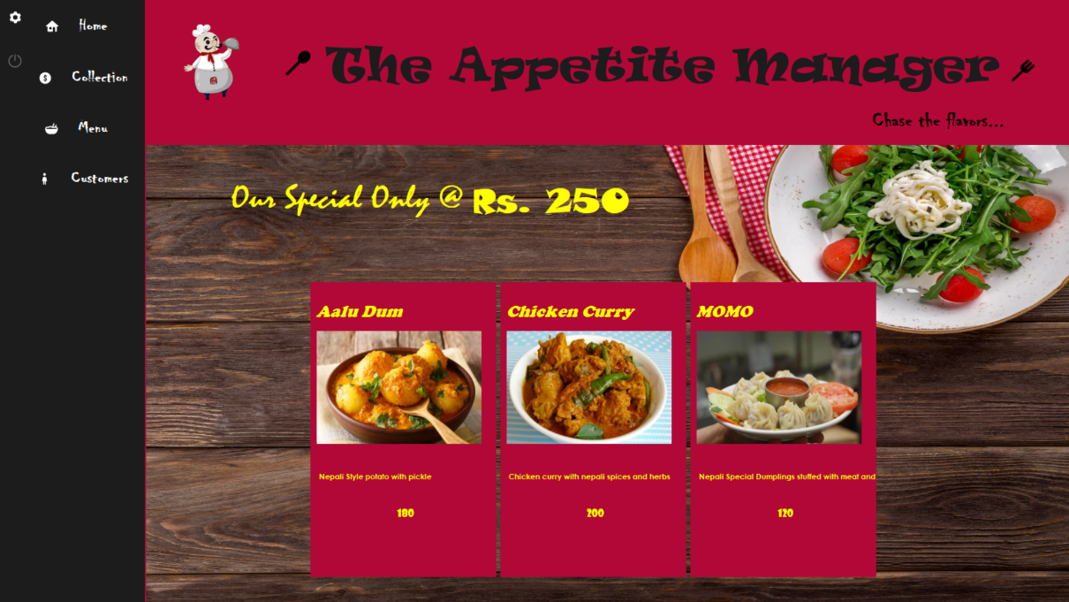Fig A: Home Screen

Fig B: 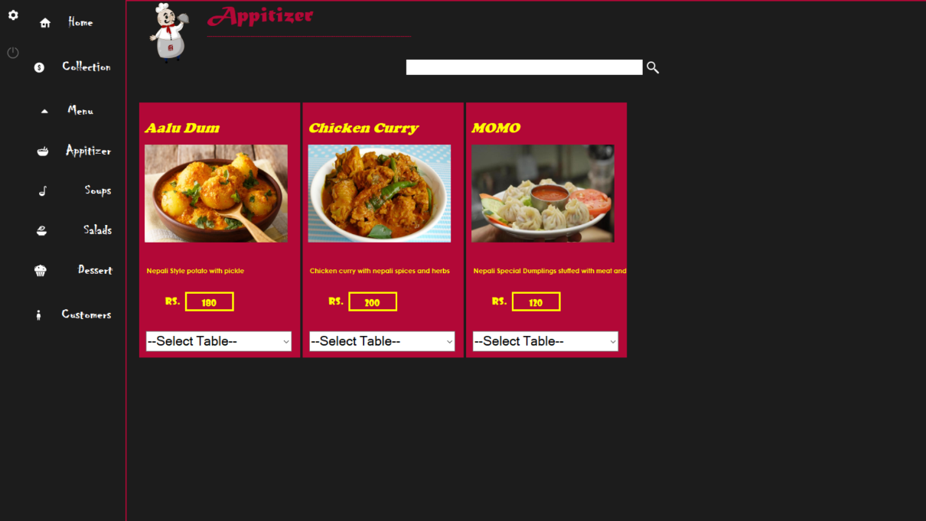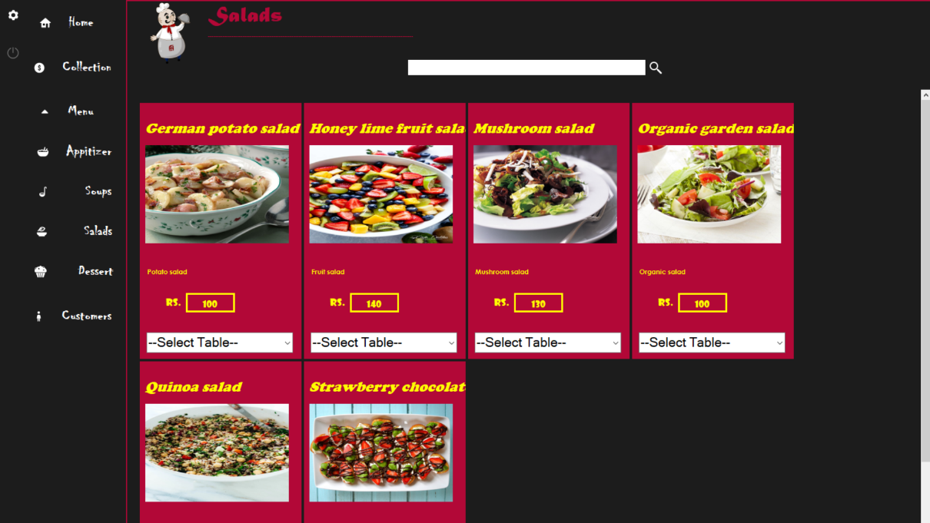Menu Display

Fig C: Table Data Loader 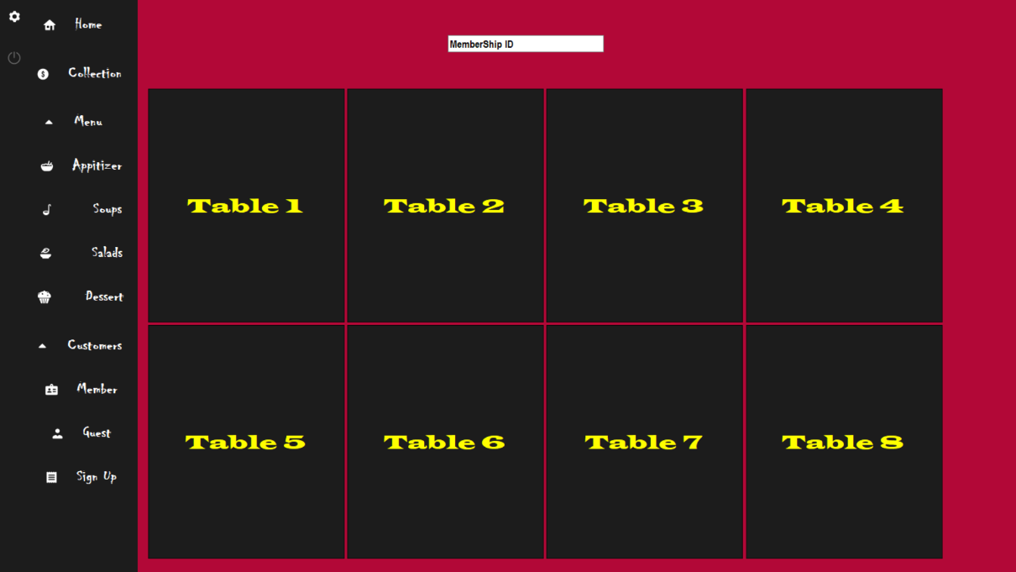

# 

Fig D: Membership Signup

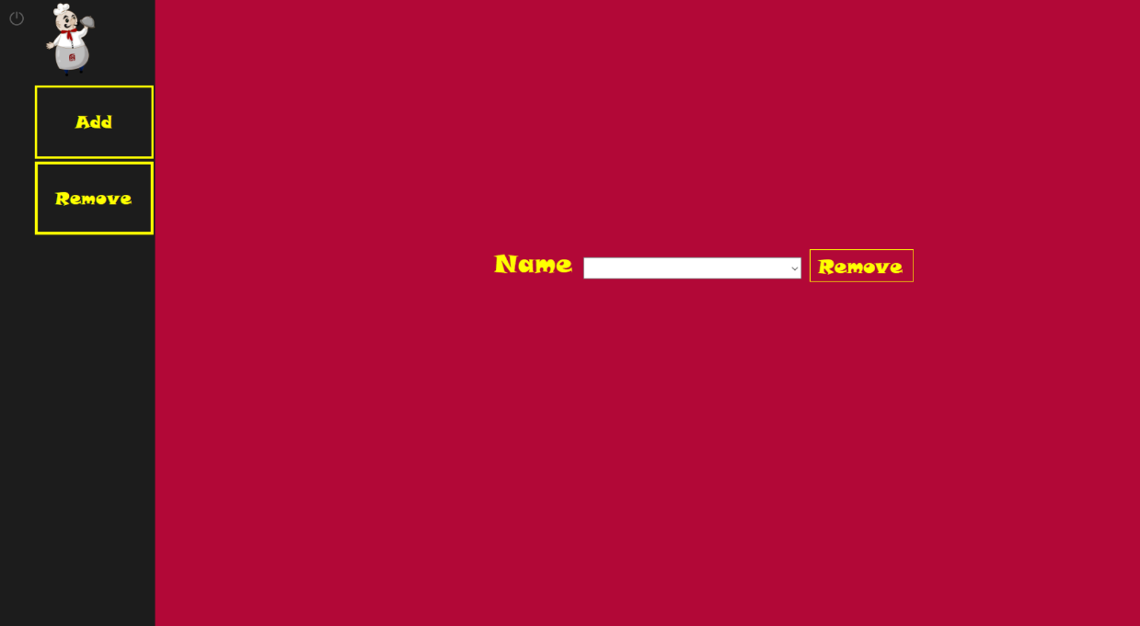Fig E: Add New Dish 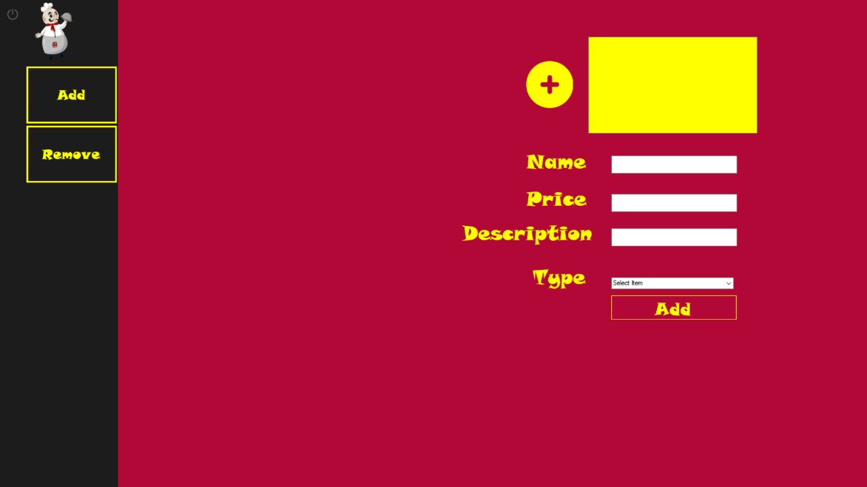

Fig F: Remove Existing Dish

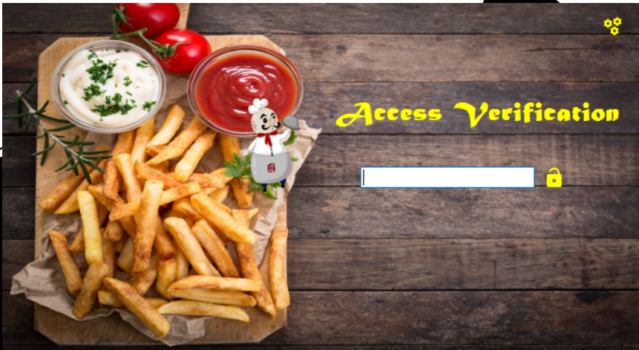

Fig G: Login Screen

# **REFERENCES**

The following references were used for the completion of the project

* Alan Cooper, “The Essential of User Interface Design”, Wiley Dream India P.ltd
* Jeffrey A.Hoffer “Modern System Analysis and Design”